Aman Patel

April 4, 2021

CSCI-B 455

Home Assignment 3 Part 2

1. Optimal separating line
   1. 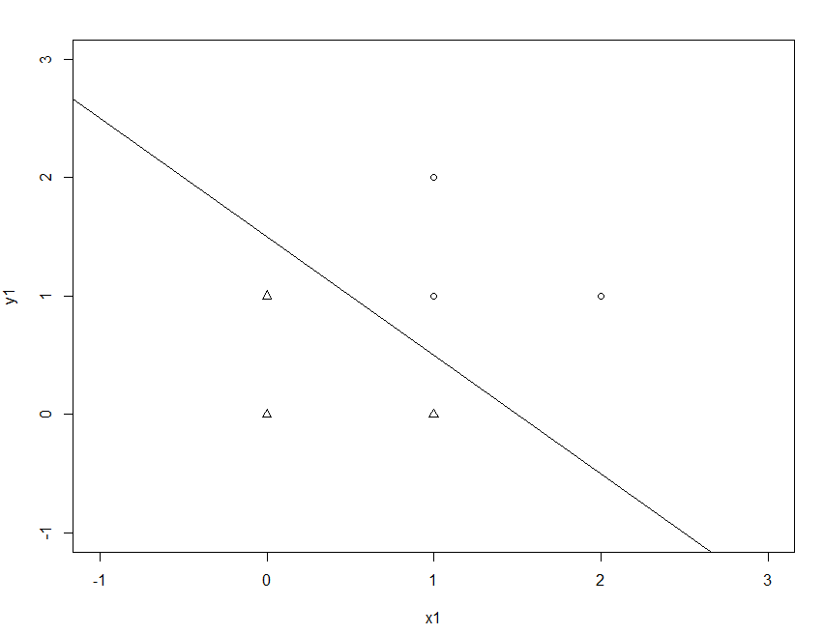Plot
   2. Supporting line: $y= -x+1.5$
   3. Support vectors: $\left(\begin{matrix}0 \\ 1\end{matrix}\right), \left(\begin{matrix}1 \\ 0\end{matrix}\right), \left(\begin{matrix}1 \\ 1\end{matrix}\right)$
   4. Margin: $\sqrt{{0.25}^{2}+{0.25}^{2}}=\frac{\sqrt{2}}{4}≈0.354$
2. Support vector machine

|  |  |  |  |
| --- | --- | --- | --- |
|  |  |  |  |
|  |  |  |  |
|  |  |  |  |

* 1. For A:
  2. For B: $λ_{A}\left(+1\right)\left(0\right)+λ_{B}\left(+1\right)\left(1\right)+λ_{C}\left(-1\right)\left(1\right)+b= +1$
 $λ_{B}-λ_{C}+b= +1$

 3. For C: $λ_{A}\left(+1\right)\left(1\right)+λ_{B}\left(+1\right)\left(1\right)+λ_{C}\left(-1\right)\left(2\right)+b= -1$
 $λ_{A}+λ_{B}-2λ_{C}+b=-1$

 $λ_{A}+λ_{B}-2λ_{C}+2b=2$

$b=3, λ_{A}=2, λ_{B}=2, λ_{C}=4$

4. Classify $D= (0, 2)$

$K\left(A, D\right)=2, K\left(B, D\right)=0, K\left(C, D\right)=2$

$λ_{A}\left(+1\right)\left(2\right)+λ_{B}\left(+1\right)\left(0\right)+ λ_{C}\left(-1\right)\left(2\right)+b=-1, ∴Class 1$

1. See attached notebook.
2. Yes, neural networks can be used for sentiment analysis. First, the input text will be tokenized to isolate each word. Then, each word is embedded to convert from string to integer. Each of these integers can be used as inputs in the network, which will output the overall sentiment of the text: positive, negative, or neutral. To train the network, a vast collection of text (corpus) can be used to show the general connotation of each word and some variations of the usage of each word.